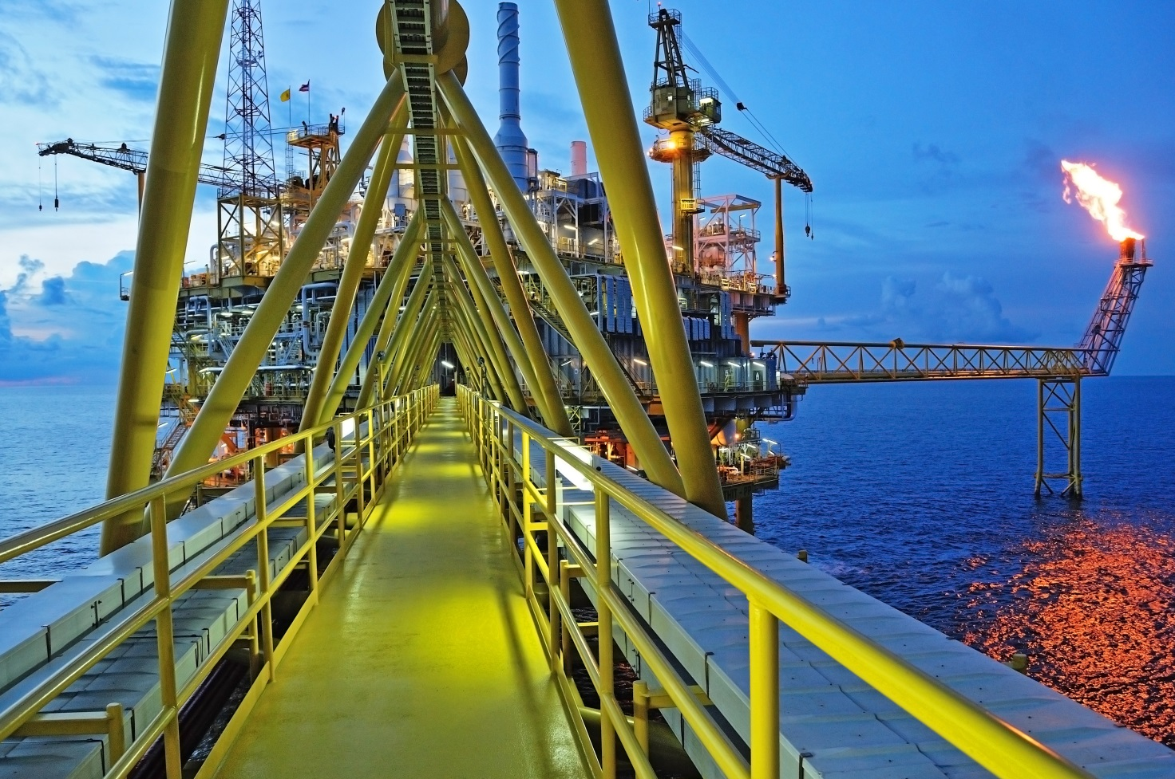

**Sarebbe meglio se la fiamma non comparisse perchè al momento è in eliminazione da tutte le piattaforme per motivi ambientali**



The Oil&Gas industries is actually dealing with several technical and market  challenges as the operation in unfamiliar environment, the need of optimization of mature assets, the environment respect, the lack of human capital and the price volatility.

We strongly believe that the answers to this challenges come from innovation and the customer proximity.

Chimec is committed in the design of effective treatments and reliable new technologies in the field of the production chemistry.

The solutions we can provide range from the Asset Integrity Management to the Flow Assurance passing through the Process and Production Optimization.

Each solution is aimed to answer to the specific issues of the asset ant to target the requested specifications. Each solution is based on the use of the proper chemical supported by high level field service and it is included in a continuous development product cycle. We name this approach as tailor made solution.

Thank to this approach, in the Oilfield Development & Marketing Department we are supporting our clients day-by-day in facing challenges since more than 40 years.

**Asset Integrity Management - AIM**

A proper plant management is mandatory to reach the life design of the assets. To accomplish the target, it is mandatory to put in place effective measures for risk assessment and control.

Our long term experience and know-how allow us to be a trustworthy partner for the development and management of chemical treatments that can be integrated in the AIM strategies to control any kind of corrosion and biofouling, as well as enhance the process and its relevant CAPEX and OPEX.

We support our clients in defining the most competitive strategies and their ROI looking also to the safety and the environment preservation.

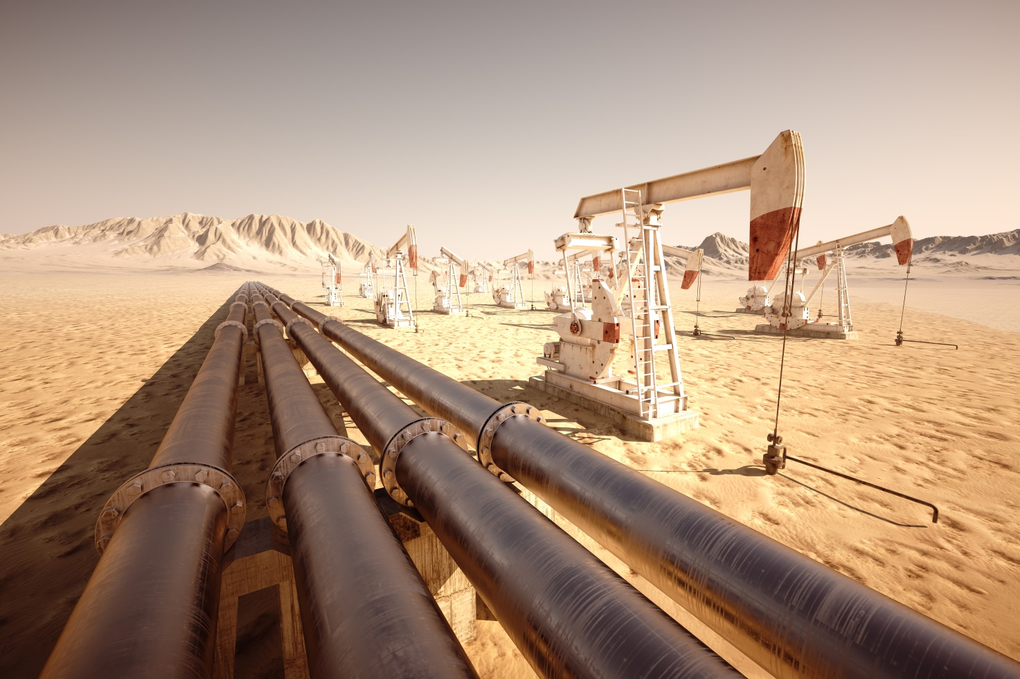

**Process and Production Optimization**

The philosophy behind our approach in process and production optimization is to apply tailor made solutions based on chemical selection and treatment design in order to achieve the production targets.

Together with the client, we study and define the proper strategy to maintain or increase the field production with solutions that can be applied from down hole to the shipping line.

We assure a reliable support in the management of the whole process from the survey to the treatment optimization providing solutions with profitable ROI.

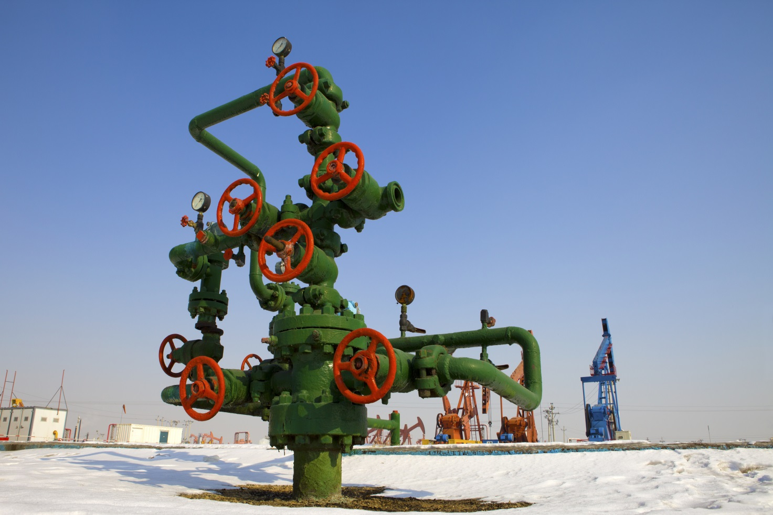

**Questa foto tagliata orizzontalmente perde significato quindi sarebbe preferibile una struttura del paragrafo con testo a lato della foto.**

**Flow Assurance**

Flow Assurance is becoming more and more important since companies started to exploit high viscosity crudes, non-conventional reservoirs and hostile environment areas. CHIMEC took up this challenge finding innovative strategies to ensure a successful and economically sustainable flow of hydrocarbon stream from the reservoir to the point of sale.

Our approach is based on the application of advanced software and analytical techniques in the selection, investigation and monitoring.

Our solutions are plant integrated, environmentally friendly, effective and cost saving.

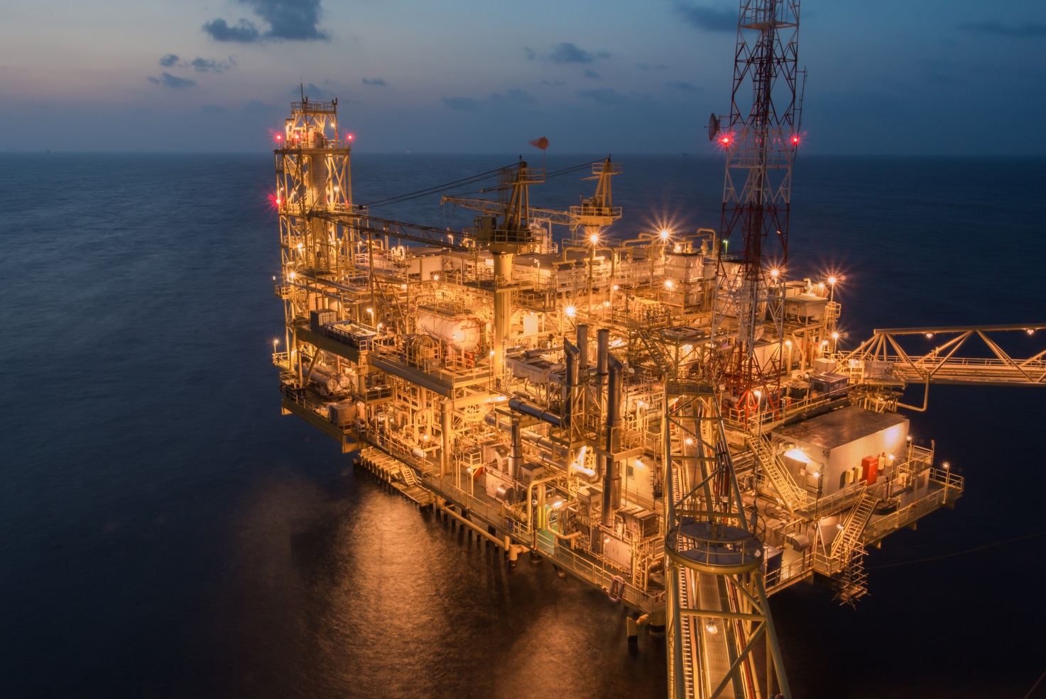

**Ho ipotizzato un taglio ma come nel caso della foto precedente sarebbe preferibile una disposizione testo a lato**

**Chimec PhoenixTech: foamers for well deliquification**

Gas well depletion can be worse than expected if liquid loading is occurring. Over time, hydrostatic pressure increases and gas velocity could get below the critical one, thus gas is not more able to lift water and condensate up to surface. **Chimec PhoenixTech** is the solution that restores the production bringing the well to a second life. This result is obtained thanks to the use of foaming agents that help the gas to displace the liquid topside, restoring the well production to the expected one

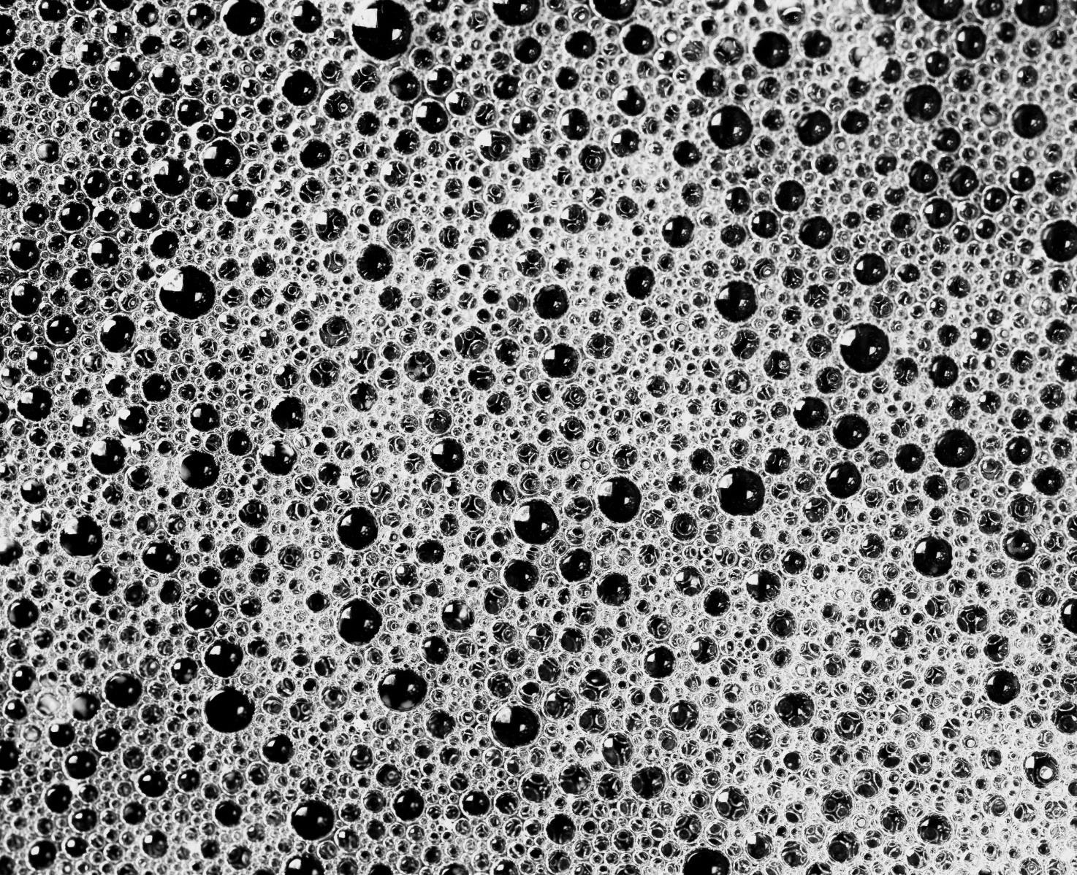

**La foto di base è Bianca e ner aper favore applicate voi la colorazione ocra. Per darvi un’idea ho inserito nella cartella delle foto vere fatte da noi.**

**Chimec Atlantis: Homologated Products for well Deep Water**

Deep Water and Ultra Deep Water operations deal with extremely challenging environments. Low temperature and high pressure can lead to Flow Assurance related issues.

Chemical injection may cause damages and blockage, this risk may be reduced providing chemicals which are stable in critical P/T conditions, requiring high purity and compatibility with umbilical and capillary materials and also with system fluids.

The consequence of injection system failures can be severe in CAPEX (umbilical substitution) and OPEX (remedial intervention, poor performance) terms, deferred production and marine environment impact.

Atlantis is the Chimec product range dedicated to Deep Water. To guarantee that each Chimec Atlantis product is fit-for-purpose, Chimec implements an Internal Homologation Protocol based on more than 16 specific laboratory tests to assure Performance, Pumpability, Handling, Compatibility with materials and fluids and a sustainable Environmental Profile.

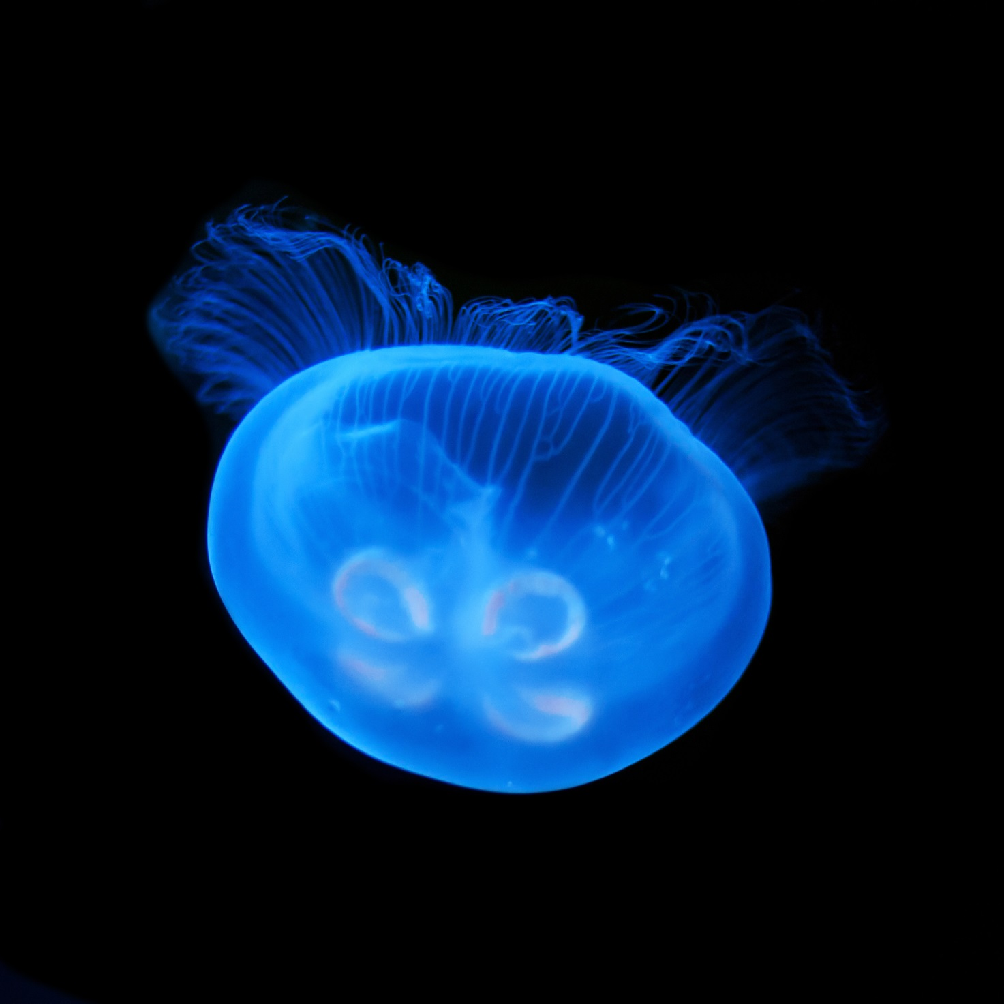

**Questa foto tagliata orizzontalmente perde significato quindi sarebbe preferibile una struttura del paragrafo con testo a lato della foto.**

**Chimec Salt Dispersant**

Sodium Chloride is the most abundant salt in oil and gas field production waters. When the production is coming with saturated or near to saturation water, the risk of NaCl deposition is high. The deposition can occur everywhere in the plant, from bottom hole to the shipping lines. Also low water cut hydrocarbon streams can experience deposition especially if heated above the boiling point. **Salt Dispersant** is the technology developed to protect all the assets from the consequences of NaCl deposition as Flow Assurance and Asset Integrity issues. The **Salt Dispersant** is able to interact with the microcrystals during both the nucleation phase and once the deposition is occurred. Thanks to its action the microcrystals are reversibly dispersed in the oil phase, reducing the salt content of the water.

