# DEKO Development & Marketing develops technological solutions aimed to provide our clients full technical support during planned or unscheduled shutdowns.

# DEKO is a CHIMEC technology able to guarantee a drastic reduction of the shutdown time and optimal safety conditions.

The main advantages of our technology are:

* Hydrogen Sulphide (H2S) knockout
* Gas and light hydrocarbons stripping enhancement
* Very effective de-oiling action
* Drastic reduction of deposits
* Minimization of pyrophoric ignition risk
* Odor abatement
* Waste water reduction
* Easy waste water disposal (directly to WWTP without any pre-treatments)

**DEKO** may be applied in Refineries, Petrochemical Plants and Oil-fields. For more details please consult our application list (link)

**DEKO APPROACH**

The growing success of our DEKO technology is based on the highly expertise of our technician in planning and executing the decontamination as well as on the possibility to benefit from a broad portfolio of highly performing chemicals (link su performing chemical).

Our Decontaminations always include a package of tailored solutions, whose success strictly depends on the **Design Phase** involving both CHIMEC and the client. This first step, often not properly valorized, is the key to select the most suitable application, products, choose the optimal operating procedure and minimize the costs. (Read more)

According to our experience the achievement of the targets is anyhow possible only if an appropriate **Monitoring Strategy** is as well implemented.

The **Monitoring Startegy** allows a concrete and effective time optimization and thus an effective global cost reduction of the turnaround activities.(Read more)

Please contact our expert for further details on the benefits of our DEKO technology (email di contatto deko@chimec.it)

**DEKO SPECIAL APPLICATIONS**

**Efficiency Recovery**

**DEKO** can assure an optimal efficiency recovery of several facilities, such as heat exchangers, absorbers and distillation columns. It provides great time saving during the unit shutdown by drastically reducing all the activities commonly required by a classic mechanical cleaning approach.

**DEKO/eKO**

An ecofriendly synergy between two applications, **DEKO** and **Emission Knock-Out.** It’s able to guarantee gas-free conditions as well as emissions neutralization through the application of specific and effective chemicals.

**Tank DEKO/Cleaning**

Can be applied both to upstream and downstream processes for a wide range of deposits. It is able to assure a high level of cleaning and safety, as well as gas free conditions and significant time saving.

**___________________________________________________________________________________**

**MAIN APPLICATIONS**

**Refineries**

Desalters

Topping Units

Vacuum Units

FCC Units

HDS Units

MEROX Units

Visbreaking Units

Light Ends Units

Amine Units

Flare lines

Knock-out drums

SWS Units

**Petrochemicals**

Steam Cracking Units

Aromatics extraction

Butadiene units

**Oilfields**

Slug catchers

3-phase separators

Stabilizers

Sweetening units

Dehydration units

Gas Filters

FPSO

**__________________________________________________________________**

(Testo per pagina Design Phase)

The **Design Phase** is the key for a successful result. In this phase the project can be studied and planned in every detail, all the available technologies are investigated to select the most suitable to achieve the technical targets. This phase is also essential to define all the solutions able to guarantee the highest safety standards and the minimization of every potential risk.

The aim of the **Design Phase** is to define:

* The flow optimization (for both vapor phase and liquid recirculation)
* The most performing chemicals/approach
* The optimal process parameters identification (temperatures, pressures, flow rates)
* The best monitoring strategy (strategic points definition, type of analysis and their frequency, process follow up, personnel in site optimization)
* The technical staff required

The **Design Phase** is also crucial for the safety aspects, that must be evaluated to plan all the necessary preventive and protective measures. In this phase we determine:

* A complete safety data collection
* The appropriate PPE (Personal Protection Equipment) according  to the contaminants present in the work environment
* The most appropriate sample systems according to the conditions of the sample to be collected and analyzed

At the end of the Design Phase the stategy chosen and the relevant information are shared with all the people involved in planned meetings during which a complete and precise DEKO Plan is distributed.

(Fine testo per pagina Design Phase)

__________________________________________________________________________________________

(Inizio testo Monitoring Strategy)

The "around the clock "presence of **CHIMEC Specialized Personnel** during the DEKO activities will ensure a complete and constant follow up of the process, in detail

* **Sample collection and contaminants analysis**

Samples are frequently collected in order to evaluate the process of decontamination . Additives concentration and the trend of the contaminants are strictly monitored. The sampling frequency is defined according to the criticality of the point and can be even each hour

* **Process parameters and conditions control**

Continuous monitoring of pressures and temperatures of the whole system through control room data analysis and field instruments. Continuous flows monitoring and control on draining systems. Identification of cold spots and contaminated condensate accumulation, which are dangerous to the DEKO PROCESS

All these activities, followed by eventual troubleshooting actions , let us achieve the target required, minimizing the time and maximizing the safety.

**(Fine testo Monitoring Strategy)**

**DEKO PRODUCT RANGE**

The success of CHIMEC DEKO technology is also due to the availability of a broad portfolio of chemicals which guarantee the maximum flexibility in the Design Phase and Execution, increasing to the highest level the percentage of successful decontamination.

Each line was developed in order to satisfy specific field requirement.

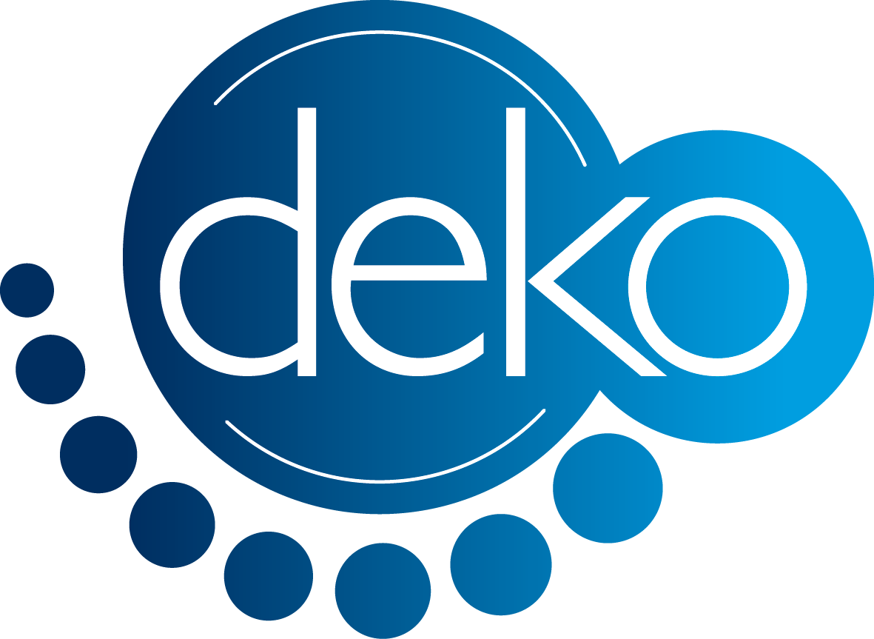

**Vapor Phase**

**Liquid Phase**

**Deko Shield**

**Deko Polybreak**

**Deko Sharp**

**Deko Switch**

**Deko Catcher**

**Deko Power**

**Deko Tank**

**Deko**

**Oxy**

**DEKo Shield:**

Versatile additive applicable in liquid and vapor phase. It has degassing, cleaning and oxidizing propertis

**DEKO Polybreak**

Applicable in aqueous liquid phase, strong solvent and dispersant action

**Deko Sharp**

A diversified line of products applicable both in oil and water liquid phase, strong solvent and dispersant action

**DEKO Switch**

A complete line of strong demulsifier suggested when stable emulsion are generated

**DEKO Catcher**

A strong demulsifier including specific agent which may catch VOC’s if the additive is nebulized

**DEKO Power**

A complete line of products developed for the removal of inorganic deposits

**DEKO Tank**

Our line of chemicals dedicated to the tank cleaning

**DEKO Oxy**

Specifically designed to fight the pyrophotic risk and avoid PSCC (Polytionic Stress Corrosion Cracking)